Education Committee Vacant Position Application Form
Name:
CSVS Number:
AVS? (please circle) | Yes / No
If yes, date of AVS:
Vacancy applying for:
A bit about yourself and your reason for applying:

We appreciate your expression of interest.

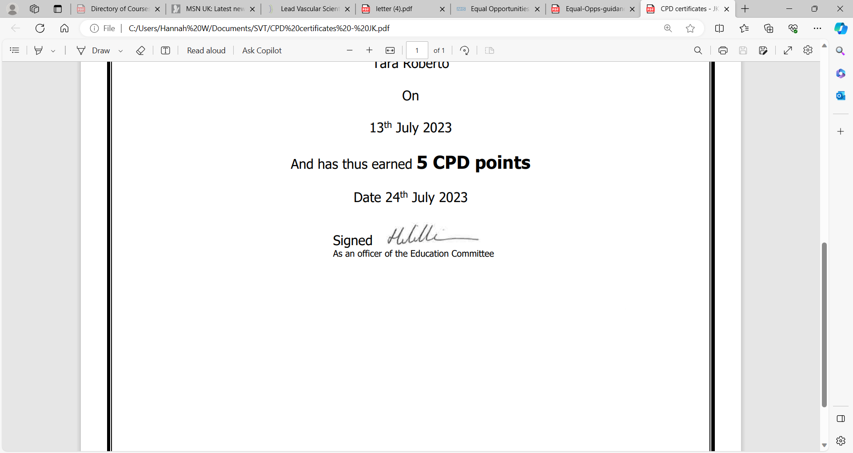
Hannah Williamson
Chair of CSVS Education Committee

